Householder transformation

function: Euclidean Norm Calculation for Vectors

Purpose: This function calculates the Euclidean norm (magnitude) of a vector v of length len.
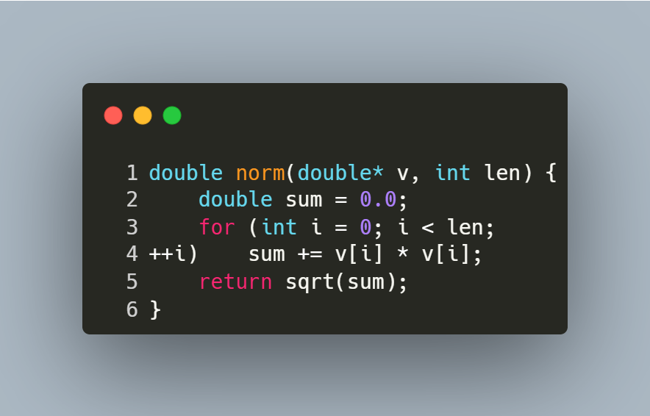
Step-by-Step Explanation
- Initialization:
  - double sum = 0.0; initializes a variable to accumulate the sum of squared elements.
- Loop Through Elements:
  - for (int i = 0; i < len; ++i) iterates over each element of the vector.
- Sum of Squares:
  - sum += v[i] * v[i]; squares each element and adds it to sum.
- Final Calculation:
  - return sqrt(sum); returns the square root of the accumulated sum, giving the Euclidean norm.

function: Matrix Multiplication for Square Matrices

Purpose: This function multiplies two square matrices A and B of size n x n and stores the result in matrix C.
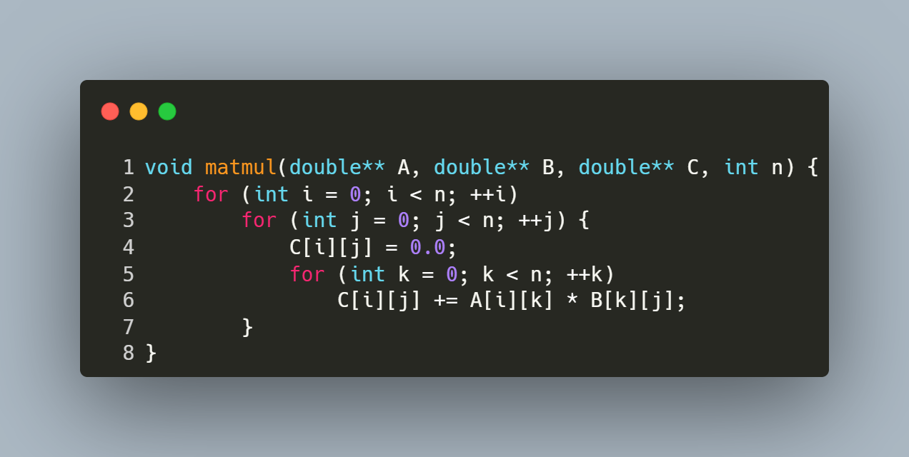
Step-by-Step Explanation
- Row Iteration (i loop):
  - Iterates over each row of matrix A (from 0 to n-1).
- Column Iteration (j loop):
  - For each row i, iterates over each column of matrix B (from 0 to n-1).
- Element Initialization:
  - C[i][j] = 0.0; resets the target element in C to zero to avoid garbage values.
- Dot Product Calculation (k loop):
  - Computes the dot product of the i-th row of A and the j-th column of B.
  - Accumulates the sum of products: C[i][j] += A[i][k] * B[k][j];.
- Result Storage:
  - After the k loop completes, C[i][j] holds the final value for the element at row i, column j of the product matrix.

function: Matrix Transposition

Purpose: This function computes the transpose of a square matrix src of size n x n and stores the result in another matrix dst.
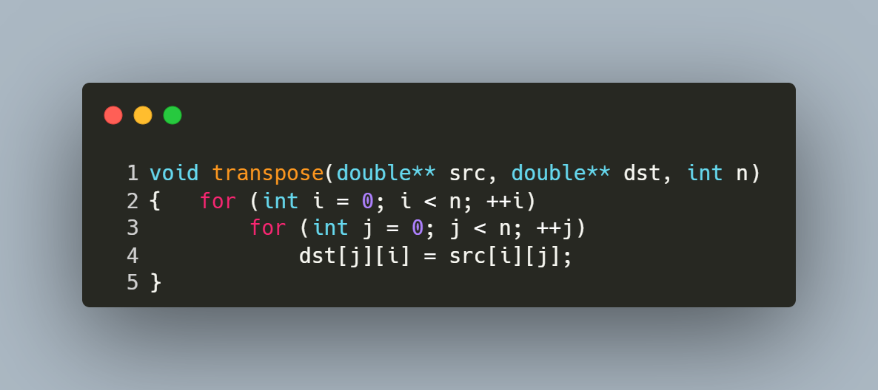
Step-by-Step Explanation
- Outer Loop (i loop):
  - Iterates over each row of the source matrix src (from 0 to n-1).
- Inner Loop (j loop):
  - For each row i, iterates over each column of the source matrix src (from 0 to n-1).
- Transpose Operation:
  - The element at position (i, j) in the source matrix is assigned to position (j, i) in the destination matrix:
    - dst[j][i] = src[i][j];.
- Result Storage:
  - After all iterations, the destination matrix dst contains the transpose of the source matrix src.

function: QR Factorization Using Householder Reflections

Purpose: This function performs QR decomposition of a square matrix A into an orthogonal matrix Q and an upper triangular matrix R using Householder reflections.
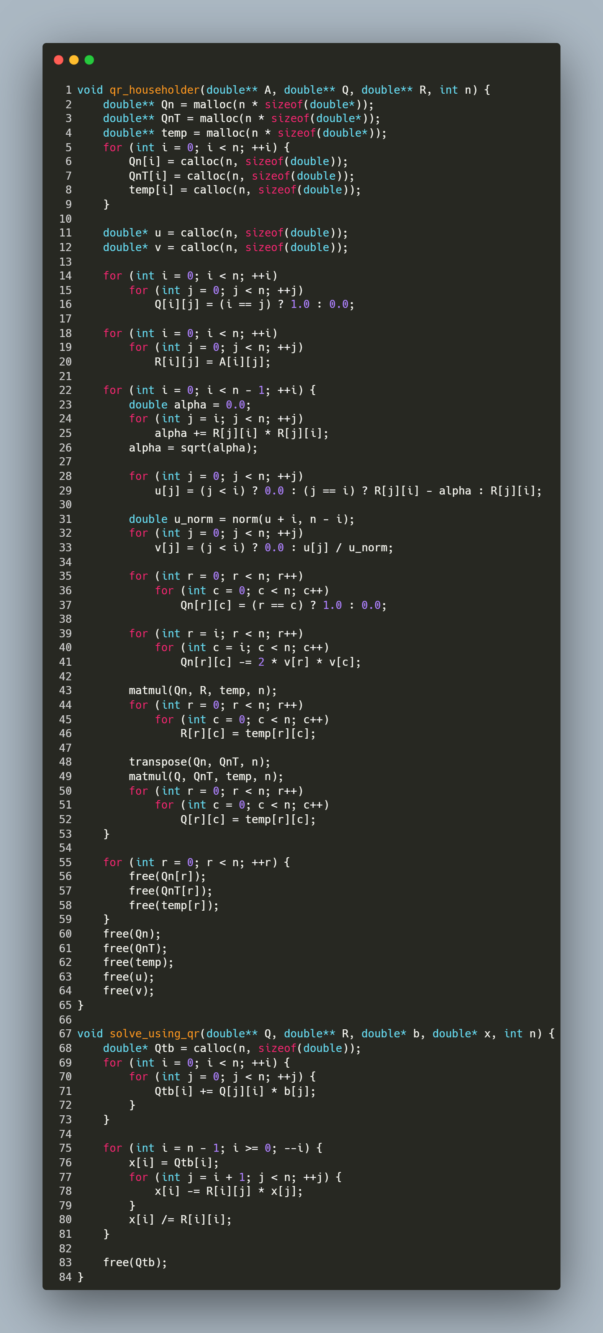
Step-by-Step Explanation
1. Memory Allocation & Initialization
- Temporary Matrices/Vectors:
  - Qn: Stores the Householder reflection matrix for the current iteration.
  - QnT: Stores the transpose of Qn.
  - temp: Temporary matrix for intermediate calculations.
  - u, v: Vectors used to construct the Householder reflection.

double** Qn = malloc(n * sizeof(double*));
double** QnT = malloc(n * sizeof(double*));
double** temp = malloc(n * sizeof(double*));
for (int i = 0; i < n; ++i) {
Qn[i] = calloc(n, sizeof(double));
QnT[i] = calloc(n, sizeof(double));
temp[i] = calloc(n, sizeof(double));
}
double* u = calloc(n, sizeof(double));
double* v = calloc(n, sizeof(double));
- Initialize Q and R:
  - Q starts as an identity matrix.
  - R is initialized as a copy of A.
for (int i = 0; i < n; ++i)
for (int j = 0; j < n; ++j)
Q[i][j] = (i == j) ? 1.0 : 0.0; // Identity matrix

for (int i = 0; i < n; ++i)
for (int j = 0; j < n; ++j)
R[i][j] = A[i][j]; // Copy A into R
2. Householder Reflections (Main Loop)
For each column i from 0 to n-2:
Step 2.1: Compute Reflection Vector u
- Calculate alpha:
  - alpha is the Euclidean norm of the sub-column of R below (and including) the diagonal element R[i][i].

double alpha = 0.0;
for (int j = i; j < n; ++j)
alpha += R[j][i] * R[j][i];
alpha = sqrt(alpha);
- Construct u:
  - u is a vector where:
    - Elements above index i are zero.
    - At index i: u[i] = R[i][i] - alpha (to avoid cancellation errors).
    - Below index i: u[j] = R[j][i] (original column elements).
for (int j = 0; j < n; ++j)
u[j] = (j < i) ? 0.0 : (j == i) ? R[j][i] - alpha : R[j][i];
- Normalize u to get v:
  - Compute the norm of u (starting from index i).
  - v = u / ||u|| to create a unit vector.
double u_norm = norm(u + i, n - i);
for (int j = 0; j < n; ++j)
v[j] = (j < i) ? 0.0 : u[j] / u_norm;
Step 2.2: Build Householder Matrix Qn
- Formula: Qn = I - 2 * v * vᵀ, where I is the identity matrix.
- Implementation:
  - Initialize Qn as an identity matrix.
  - Subtract 2 * v * vᵀ from Qn for rows/columns >= i.
for (int r = 0; r < n; r++)
for (int c = 0; c < n; c++)
Qn[r][c] = (r == c) ? 1.0 : 0.0;

for (int r = i; r < n; r++)
for (int c = i; c < n; c++)
Qn[r][c] -= 2 * v[r] * v[c];
Step 2.3: Update R and Q
- Update R: Apply Qn to R to zero out sub-diagonal elements in column i.
matmul(Qn, R, temp, n);
for (int r = 0; r < n; r++)
for (int c = 0; c < n; c++)
R[r][c] = temp[r][c];
- Update Q: Accumulate the reflection into Q by multiplying with Qnᵀ.

transpose(Qn, QnT, n);
matmul(Q, QnT, temp, n);
for (int r = 0; r < n; r++)
for (int c = 0; c < n; c++)
Q[r][c] = temp[r][c];
3. Cleanup
- Free all dynamically allocated temporary matrices and vectors:

function: Solving Linear Systems Using QR Decomposition

Purpose: This function solves the linear system Ax = b using the QR factorization of matrix A. It computes the solution x by first transforming b into Qᵀb and then performing backward substitution on the upper triangular matrix R.
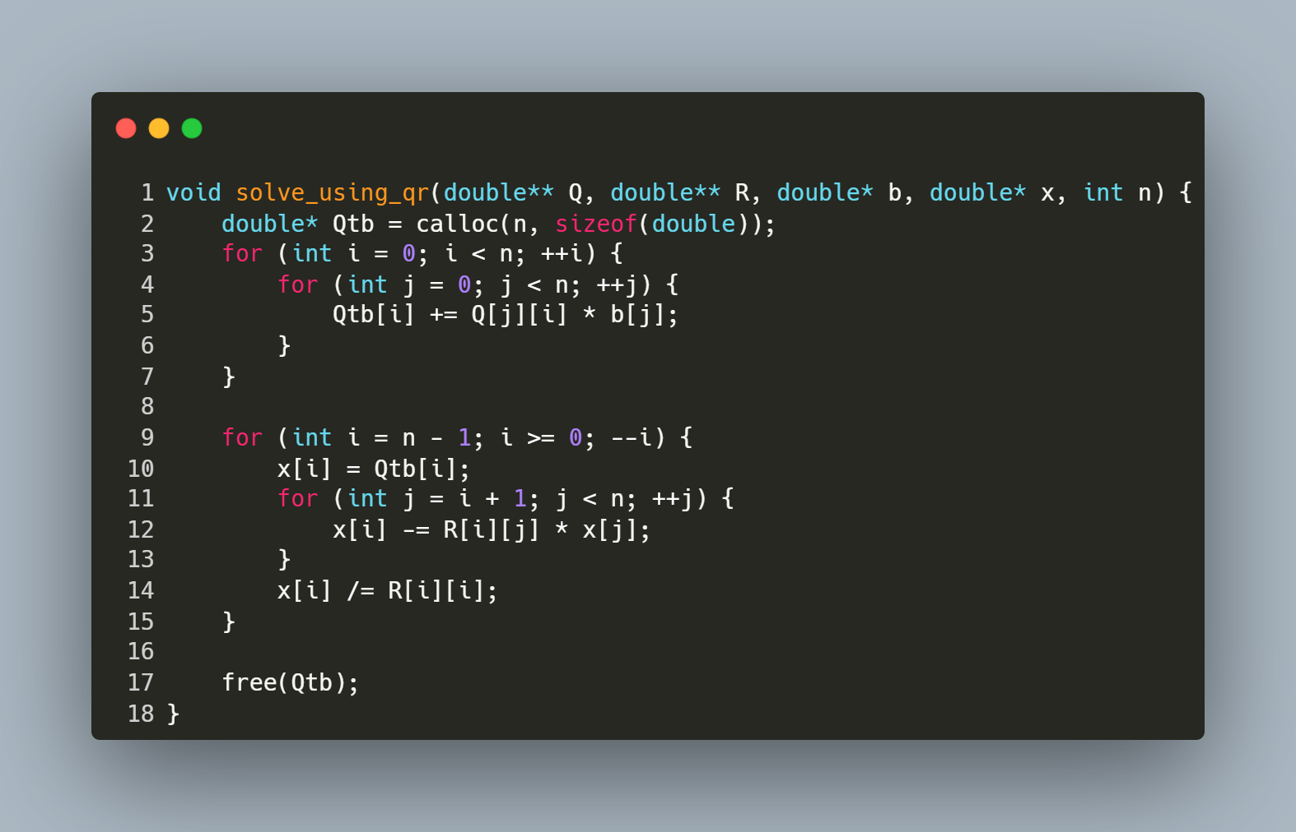
Step-by-Step Explanation
1. Compute Qᵀb
- Allocates a vector Qtb to store the product of Qᵀ (orthogonal matrix) and b.
- The nested loop calculates each element of Qtb as the dot product of the i-th column of Q (equivalent to the i-th row of Qᵀ) and b.
2. Backward Substitution
- Iterates backward from the last row (i = n-1) to the first (i = 0):
  - Initialize: x[i] = Qtb[i] (starting value for the solution element).
  - Subtract Known Terms: For each column j > i, subtract R[i][j] * x[j] to eliminate dependencies on already solved variables.
  - Normalize: Divide by the diagonal element R[i][i] to isolate x[i].

function : Reading Matrix and Vector Input from a File

Purpose: This function reads a square matrix A of size n x n and a vector b of size n from a file named "inputs.txt". It ensures proper error handling for file operations and input parsing.
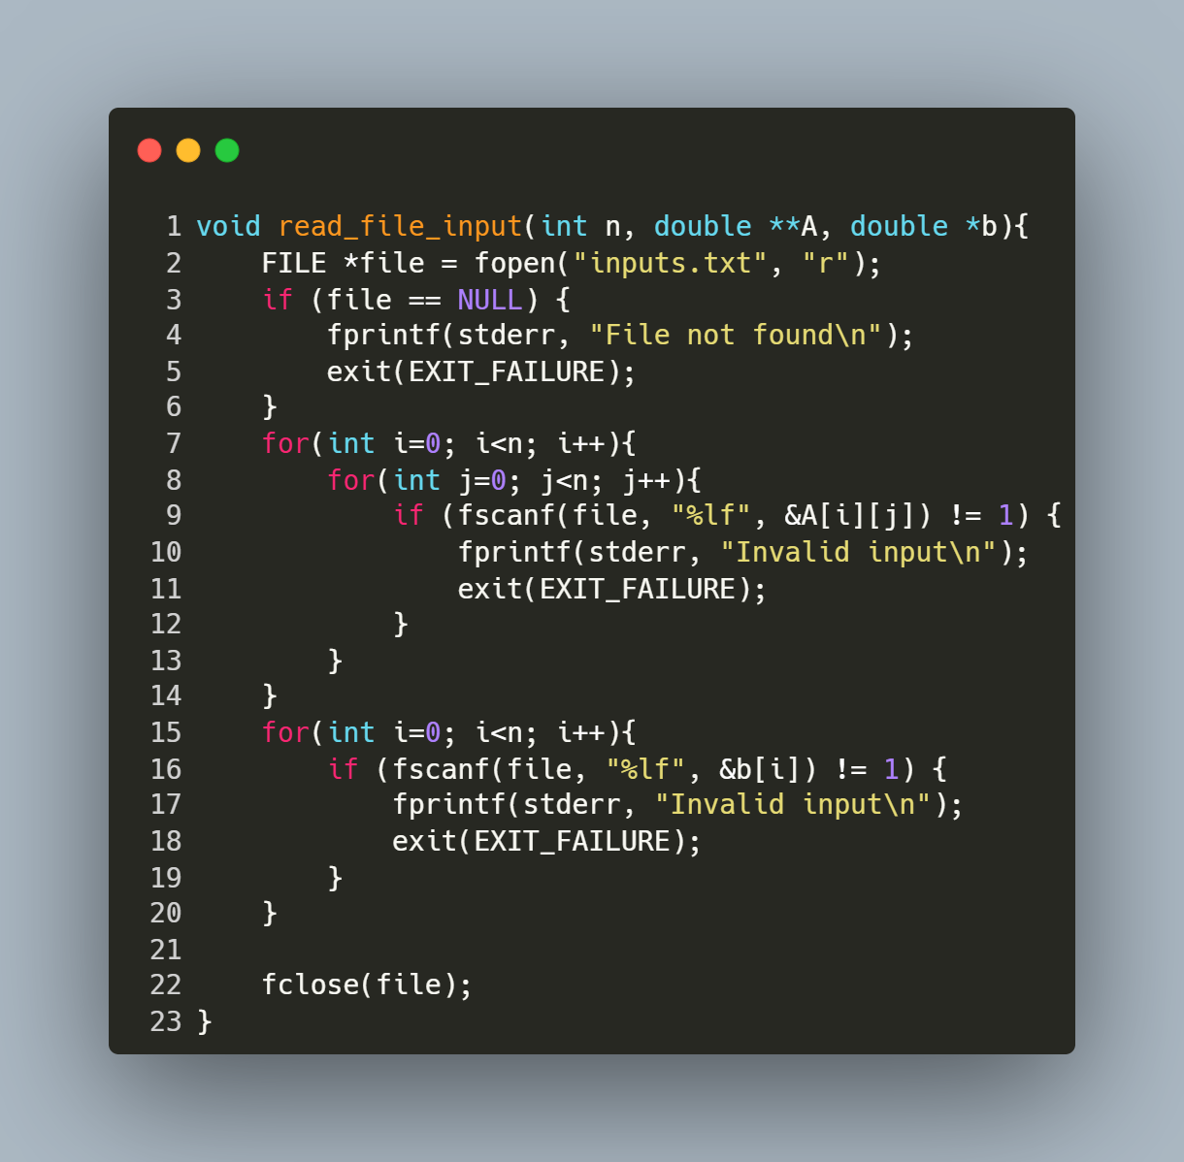
Step-by-Step Explanation
- Open File:
  - FILE *file = fopen("inputs.txt", "r"); opens the file "inputs.txt" in read mode.
  - If the file cannot be opened (e.g., it doesn't exist), the program prints an error message ("File not found") and exits.
- Read Matrix Elements:
  - The nested loop for (int i = 0; i < n; i++) { for (int j = 0; j < n; j++) { ... } } iterates through each row (i) and column (j) of matrix A.
  - fscanf(file, "%lf", &A[i][j]) reads a floating-point number from the file and stores it in the corresponding position in A.
  - If the input is invalid or missing, the program prints "Invalid input" and exits.
- Read Vector Elements:
  - The loop for (int i = 0; i < n; i++) { ... } iterates through each element of vector b.
  - fscanf(file, "%lf", &b[i]) reads a floating-point number from the file and stores it in the corresponding position in b.
  - Similar error handling ensures that invalid or missing input causes the program to terminate with an error message.
- Close File:
fclose(file); closes the file after all data has been read to release system resources.

Main Program for Solving Linear Systems via QR Factorization

Purpose: This program solves a linear system Ax = b using QR decomposition. It reads matrix A and vector b from a file, computes the orthogonal matrix Q and upper triangular matrix R, solves for x, and prints the solution, runtime, and matrix Q.
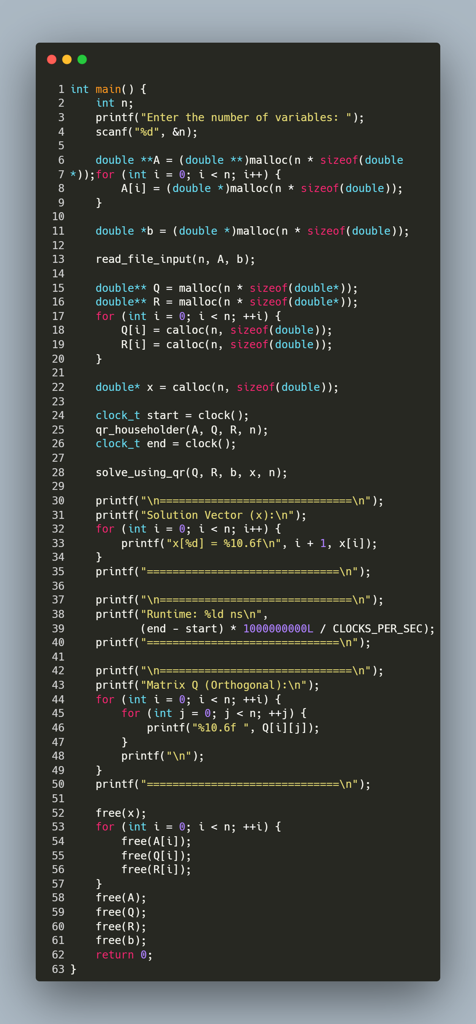
Step-by-Step Explanation
1. User Input
- Prompts the user to enter the number of variables (n).
2. Memory Allocation
- Allocates memory for:
  - A (n x n matrix) using nested malloc.
  - b (vector of size n).
  - Q and R (n x n matrices initialized with calloc).
  - x (solution vector initialized with calloc).
3. Read Input File
- Calls read_file_input(n, A, b) to populate A and b from "inputs.txt".
4. QR Factorization & Timing
- clock() records the start time.
- qr_householder(A, Q, R, n) decomposes A into Q (orthogonal) and R (upper triangular).
- clock() records the end time.
5. Solve for x
- solve_using_qr(Q, R, b, x, n) computes the solution vector x via backward substitution.
6. Print Results
- Displays the solution vector x with 6 decimal places.
- Prints the runtime in nanoseconds.
- Outputs the orthogonal matrix Q for verification.
7. Memory Cleanup
- Frees all dynamically allocated memory for A, b, Q, R, and x.

